Name of the Applicant: Total no. of sheets: 4

Saveetha Institute of Medical and Technical Sciences, T. Mani Sai Lokesh,

Dr. P. Arjun Pandian, Dr. B. Ramesh, Dr. Ramya Mohan.

Sheet no: 1 of 4

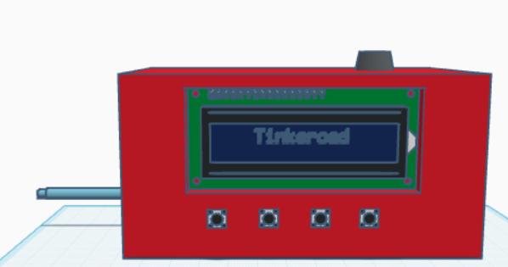

[PERSPECTIVE VIEW]

The novelty resides in the shape and configuration “**Smart Cooker Whistle Counter with Auto Shut-Off**” of the article as illustrated.

No claim is made by virtue of this registration in respect of any mechanical or other action of the mechanism whatever or in respect of any mode or principle of construction of the article.

No claim is made by virtue of the registration to any rights to the exclusive use of the words, letters, numbers, colours, colour combination or Trademarks as appearing in the representations.

Name of the Applicant: Total no. of sheets: 4

Saveetha Institute of Medical And Technical Sciences,

T. Mani Sai Lokesh, Dr. P. Arjun Pandian, Dr. B. Ramesh, Dr. Ramya Mohan.

Sheet no: 2 of 4



[FRONT VIEW]

The novelty resides in the shape and configuration “**Smart Cooker Whistle Counter with Auto Shut-Off**” of the article as illustrated.

No claim is made by virtue of this registration in respect of any mechanical or other action of the mechanism whatever or in respect of any mode or principle of construction of the article.

No claim is made by virtue of the registration to any rights to the exclusive use of the words, letters, numbers, colours, colour combination or Trademarks as appearing in the representations.

Name of the Applicant: Total no. of sheets: 4

Saveetha Institute of Medical And Technical Sciences,

T. Mani Sai Lokesh , Dr. P. Arjun Pandian, Dr. B. Ramesh, Dr. Ramya Mohan.

Sheet no: 3 of 4

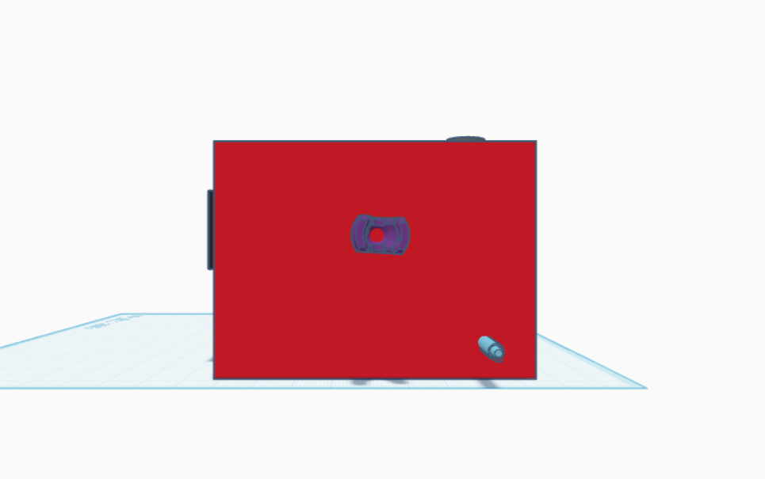

[RIGHT SIDE VIEW]

The novelty resides in the shape and configuration “**Smart Cooker Whistle Counter with Auto Shut-Off**” of the article as illustrated.

No claim is made by virtue of this registration in respect of any mechanical or other action of the mechanism whatever or in respect of any mode or principle of construction of the article.

No claim is made by virtue of the registration to any rights to the exclusive use of the words, letters, numbers, colours, colour combination or Trademarks as appearing in the representations.

Name of the Applicant: Total no. of sheets: 4

Saveetha Institute of Medical And Technical Sciences,

T. Mani Sai Lokesh , Dr. P. Arjun Pandian, Dr. B. Ramesh, Dr. Ramya Mohan.

Sheet no: 4 of 4

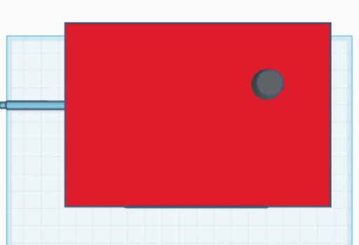

(TOP VIEW)

The novelty resides in the shape and configuration “**Smart Cooker Whistle Counter with Auto Shut-Off**” of the article as illustrated.

No claim is made by virtue of this registration in respect of any mechanical or other action of the mechanism whatever or in respect of any mode or principle of construction of the article configuration.

No claim is made by virtue of the registration to any rights to the exclusive use of the words, letters, numbers, colours, colour combination or Trademarks as appearing in the representations.